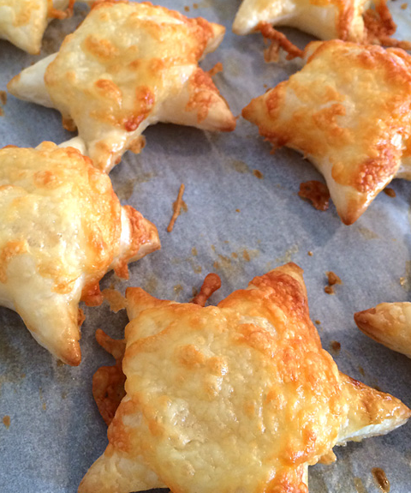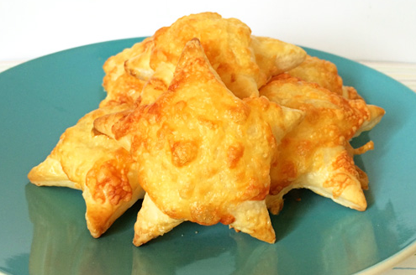Cavalry Primary School

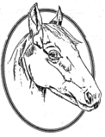

Cookery Club

**Recipe Card**

**Cheesy Puff Stars**

Ingredients

* Ready rolled puff pastry (we used two sheets)
* 1 egg
* 1 tablespoon water
* Cheese, grated (you can use Cheddar, Colby, mozzarella, Romano or Parmesan, or a combination of your favourites!)

Method

1. Preheat oven to 180C.
2. Lightly beat the egg and water together to form an egg wash.
3. Cut shapes out of your puff pastry sheets using a star-shaped cookie cutter.
4. Lay shapes onto a sheet of baking paper on your baking tray and brush with egg wash.
5. Sprinkle a little cheese onto each shape.
6. Bake for 10 minutes or until cheese has melted and pastry puffed.
7. Enjoy warm or store cooled cheese puffs in an airtight container overnight.