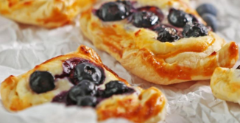
Cavalry Primary School
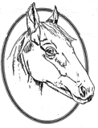

Cookery Club
Recipe Card
Fruit Pastry Tarts
Ingredients
- Puff pastry sheets
- A tub of cream cheese
- Your choice of berries
- Milk (to brush)
- Desiccated coconut or ground almonds

Method
- Mash together the cream cheese, vanilla extract and your choice of berries in a bowl.
- Cut a sheet of puff pastry into squares.
- Brush the edges with milk.
- Add a dollop of berry mixture to each square.
- Top with desiccated coconut
- Bake in the oven at 180 for 15 minutes.

