Cavalry Primary School
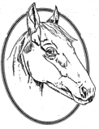

Cookery Club
Recipe Card
Mini Pea and Ham Frittata
Ingredients
- olive oil spray
- 2 slices of ham
- 1/2 cup frozen peas
- 1 tsp dried mint
- 4 eggs
- 40 g feta cheese

Method
- Preheat oven to 180°C. Spray 6 holes of a 1/2 cup muffin tin with olive oil spray.
- Mix ham, peas and mint together. Season well. Spoon mixture into prepared muffin tin.
- Beat eggs. Spoon into muffin tin over mixture. Dot the tops with crumbled feta.
- Bake for 12-14 minutes until cooked through and lightly golden.

Week 5

