Cavalry Primary School
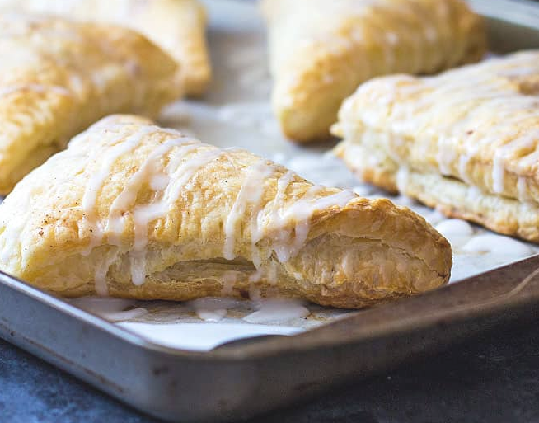

Cookery Club
Recipe Card
Mini Apple Turnovers
Ingredients
1/3 cup granulated sugar
1 tablespoon all purpose flour
1 teaspoon cinnamon, and an additional 1/2 teaspoon for sprinkling on top of turnovers
Half a cup of sultanas
2 cups cored, peeled and chopped golden delicious apples
Ready-rolled puff pastry sheets
1 tablespoon melted butter

Method
- Preheat your oven to 400 degrees F. Line a large baking sheet with parchment paper or a baking mat.
- Whisk together sugar, flour and cinnamon spice in a large bowl. Add chopped apples and toss to coat evenly. Set aside.
- On a lightly floured surface, roll out puff pastry sheets and cut each sheet into 4 even squares. Place puff pastry squares on the baking sheet.
- Spoon apple mixture (about 1/4 cup for each square) into the corner half of each square and fold to make a triangle. Press edges together, then press edges with a fork to crimp and seal.
- Brush the tops of each turnover with melted butter and sprinkle with additional apple pie spice.
- Bake for 16-20 minutes, or until golden brown.
- While turnovers are baking, prepare the glaze by stirring together powdered sugar and water (or milk) until smooth.
- Drizzle glaze over turnovers.

