Cavalry Primary School
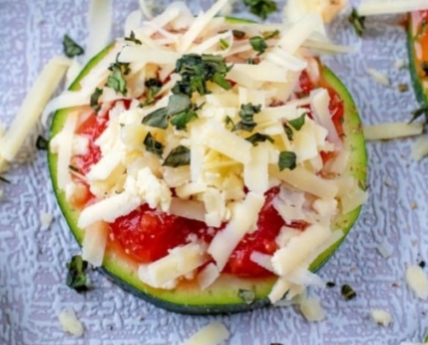

Cookery Club
Recipe Card
Courgette Pizza Bites
Ingredients
- 1 large courgette (jumbo size, if not, then 2 medium sized), cut in to 10 circles
- 10 tbsp chopped tomatoes (canned)
- 40g mature cheddar cheese
- 1 tsp dried oregano
- 1 tsp garlic powder
- 1tsp dried basil

Method
- Put the courgette slices on a baking tray and spray with a little oil. Put them under the grill for 2 minutes each side.
- Take them out of the grill and add one tbsp of chopped tomatoes to each circle.
- Sprinkle over the garlic and oregano.
- Add the cheese.
- Sprinkle the basil on top.
- Put them back under the grill for 3 minutes, until the cheese bubbles.

