Cavalry Primary School
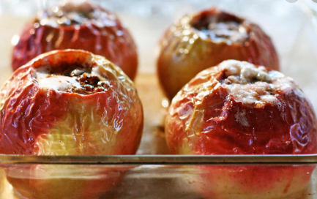
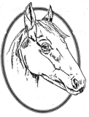

Cookery Club
Recipe Card
Baked Apples
Ingredients
- Golden Delicious/Braeburn apples
- Handful of sultanas
- 2 tbsp light muscovado sugar
- 1 tsp cinnamon
- Matchbox- sized piece of butter
- 2 tsp demerara sugar

Method
- Ask a grown-up to turn the oven on to 200C/180C fan/ gas 6.
- Sit each apple on the worktop and push the apple corer into the centre of each one (or ask a grown-up to do this for you).
- Mix the sultanas, muscovado sugar and cinnamon together in a bowl.
- Stand up the apples, side by side, in a baking dish. Using your fingers, push a little bit of the sultana mixture into each apple, using up all the mixture between them.
- Add a blob of butter to the top of each and sprinkle over the demerara sugar. Ask a grown-up to put the dish in the oven for 20 mins or until the apples are cooked through.

Week 3

