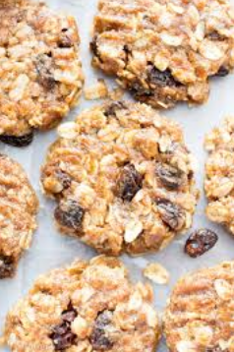
Cavalry Primary School
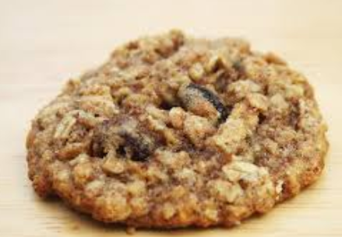

Cookery Club
Recipe Card
Healthy oatmeal & raisin cookies
Ingredients
- 3 bananas
- 150g rolled oats
- 2 tbsp raisins

Method
- Grind the oats for a few seconds to make an oat powder. It doesn’t have to be fine, they just need to be broken up a bit.
- Peel the bananas and then mash them.
- Mix everything together until combined.
- Spoon onto a non stick sheet and spread out to make a cookie biscuit shape. The mixture makes 12 normal sized cookies or 6 large.
- Bake for 15-20 mins until golden at 350°F / 180 °C.
- If you want a chewier biscuit take out of the oven as they start to get some colour. For a crunchier biscuit leave until they are golden brown.
- As they have fresh banana they will go off quickly so it’s best to eat straight away. They can be stored for a few days in the fridge but the cookies will lose their crunch.

Week 2

