Cavalry Primary School
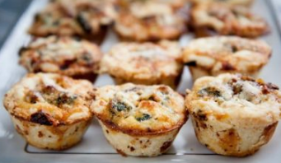

Cookery Club
Recipe Card
Mini Christmas Quiches
Ingredients
500 g turkey breast (cooked,diced)
1 onion (finely chopped)
2 cups mozzarella (grated)
1/2 cup cranberry sauce
4 eggs (beaten)
4 sheets puff pastry

Method

- Preheat oven to 180˚C and lightly grease a mini quiche or cupcake tray.
- In a large frypan, slowly fry diced turkey and onion on a moderate heat until fragrant and onion is soft.
- Take pan off the heat and add grated cheese. Allow to melt and combine.
- Add cranberry sauce and combine. Allow to cool a little.
- Add eggs and stir until combined.
- Use a round cookie/scone cutter to cut enough rounds to fill each hole in the tray.
- Fill each round of pastry with approximately 1 teaspoon of the mixture.
- Bake for approximately 15 minutes or until lightly golden.
- Repeat with remaining pastry and mixture.

