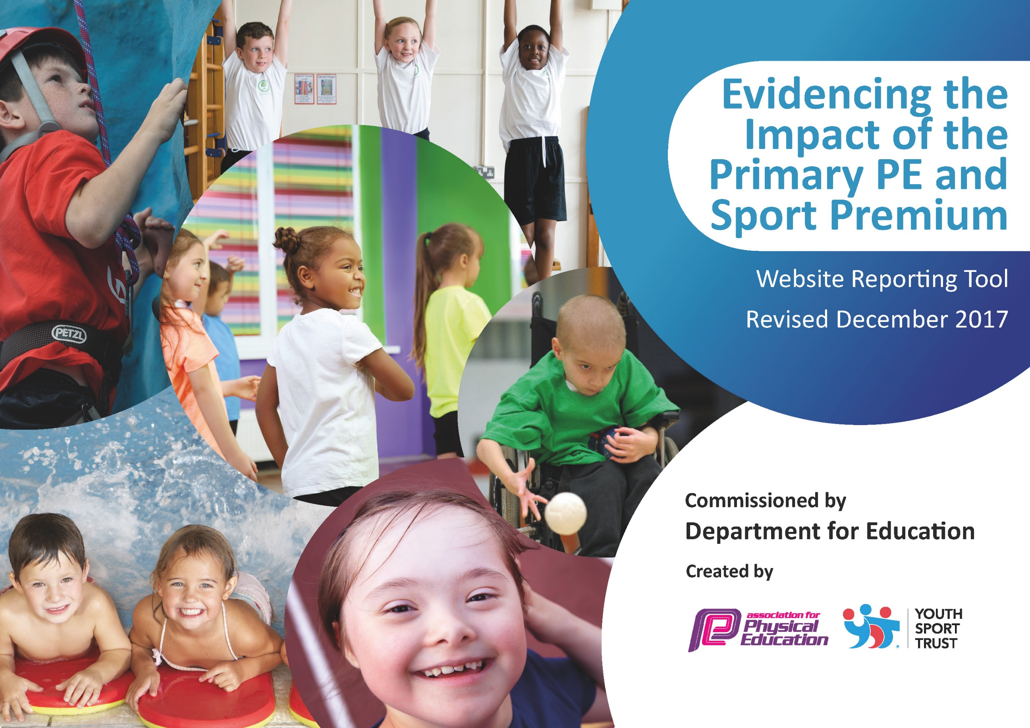

Schools must use the funding to make additional and sustainable improvements to the quality of PE and sport they offer. This means that you should use the Primary PE and Sport Premium to:

- develop or add to the PE and sport activities that your school already offers
- build capacity and capability within the school to ensure that improvements made now will benefit pupils joining the school in future years

Please visit gov.uk for the revised DfE guidance including the 5 key indicators across which schools should demonstrate an improvement. This document will help you to review your provision and to report your spend. DfE encourages schools to use this template as an effective way of meeting the reporting requirements of the Primary PE and Sport Premium.

We recommend you start by reflecting on the impact of current provision and reviewing the previous spend.
Under the Ofsted Schools Inspection Framework, inspectors will assess how effectively leaders use
the Primary PE and Sport Premium and measure its impact on outcomes for pupils, and how effectively governors hold them to account
for this.

Schools are required to publish details of how they spend this funding as well as on the impact it has on pupils’ PE
and sport participation and attainment.
We recommend regularly updating the table and
publishing it on your website as evidence
of your ongoing review into how you are using the money
to secure maximum, sustainable impact. To see an example of how to complete the table please click HERE.

Support for review and reflection - considering the 5 key indicators from DfE, what development needs are a priority for your setting and your students now and why? Use the space below to reflect on previous spend, identify current need and priorities for the future.

Cavalry Primary School
Key achievements to date: | Areas for further improvement and baseline evidence of need:
Appointment of a part time sports coach (Jan 2017) has led to:  - increased participation in after school activities  - increased participation in inter-school tournaments and competitions  - improved CPD for teachers especially in Games  - new after school club (speed stacking) is drawing in children who do not otherwise participate in extra-curricular sport  Awards for All funding paid for new trim trail.  Crazy Golf course and basic bouldering/traversing walls installed | Next steps:  - continue to monitor participation of key groups in extra-curricular activities and address gaps (e.g. boys v girls, pupil premium)  - increase quantity and quality of gymnastics teaching  - achieve School Games Gold award  - involve class teachers and midday supervisors further in promoting daily physical activity

Meeting national curriculum requirements for swimming and water safety | Please complete all of the below*:
What percentage of your current Year 6 cohort swim competently, confidently and proficiently over a distance of at least 25 metres? | 60%
What percentage of your current Year 6 cohort use a range of strokes effectively [for example, front crawl, backstroke and breaststroke]? | 60%
What percentage of your current Year 6 cohort perform safe self-rescue in different water-based situations? | 73%
Schools can choose to use the Primary PE and Sport Premium to provide additional provision for swimming but this must be for activity over and above the national curriculum requirements. Have you used it in this way? | No
*Schools may wish to provide this information in April, just before the publication deadline.

Action Plan and Budget Tracking
Capture your intended annual spend against the 5 key indicators. Clarify the success criteria and evidence of impact that you intend to measure to evaluate for students today and for the future.

Academic Year: 2018/19 | Total fund allocated: £19,600 | Date Updated:
Key indicator 1: The engagement of all pupils in regular physical activity – Chief Medical Officer guidelines recommend that primary school children undertake at least 30 minutes of physical activity a day in school |  |  |  | Percentage of total allocation:
 |  |  |  | 15%
School focus with clarity on intended impact on pupils: | Actions to achieve: | Funding allocated: | Evidence and impact: | Sustainability and suggested next steps:
- lunch time includes structured physical activity so pupils can be active for at least 30 minutes in each day. | - employ sports co-ordinator across lunch hour  - develop further role of pupil sports leaders so children lead physical activity for their peers  - additional training in active playground games for midday supervisors | £2738  £250 | - sports leaders actively involved daily  - observations show all adults outside at lunchtime are promoting physical activity
Key indicator 2: The profile of PE and sport being raised across the school as a tool for whole school improvement |  |  |  | Percentage of total allocation:
 |  |  |  | 14%
School focus with clarity on intended impact on pupils: | Actions to achieve: | Funding allocated: | Evidence and impact: | Sustainability and suggested next steps:
Work of sports co-ordinator results in PE and Sport having a high profile in the life of the school. | - maintain prominent display about PE and sports  - celebrate sports achievement through assemblies and certificates  - run a minimum of 5 sports-based clubs per week including dance  - hold annual sports days engaging parents and School Olympics day | £2738 | - display is up to date and appealing  - sports events celebrated in assemblies  - min 5 clubs per week  - sports days and school Olympics held summer tern

Key indicator 3: Increased confidence, knowledge and skills of all staff in teaching PE and sport |  |  |  | Percentage of total allocation:
 |  |  |  | 28%
School focus with clarity on intended  impact on pupils: | Actions to achieve: | Funding  allocated: | Evidence and impact: | Sustainability and suggested  next steps:
Teachers are equipped to teach Games with confidence and a high level of knowledge and skill. | - sports co-ordinator works alongside each teacher from Y2 to Y6 for one lesson per week to model planning, delivery and subject specific teaching skills. | £5476 | - survey of teachers shows CPD is helpful and valued
Key indicator 4: Broader experience of a range of sports and activities offered to all pupils |  |  |  | Percentage of total allocation:
 |  |  |  | 34%
School focus with clarity on intended  impact on pupils: | Actions to achieve: | Funding  allocated: | Evidence and impact: | Sustainability and suggested  next steps:
Track pupil participation levels; listen to pupil voice to see where breadth of experience could be increased, so that children have a broad experience of sport and PE | - membership of Witchford Sports Partnership (Improve IT) enables whole year groups to access festivals in a range of sports  - School Olympics Day  - continue speed stacking activities  - purchase equipment to all a wider range of sports to be delivered  - PPA cover teacher is used to strengthen provision in Gymnastics (this is NOT funded by Sports Premium) | £1400  £5248 | - equipment purchased to strengthen existing offer and extend to new sports/activities
Key indicator 5: Increased participation in competitive sport |  |  |  | Percentage of total allocation:
 |  |  |  | 9%
School focus with clarity on intended  impact on pupils: | Actions to achieve: | Funding  allocated: | Evidence and impact: | Sustainability and suggested  next steps:
Increase internal opportunities for competitive sport activities to match the inter-school activities already on offer. | - in KS2 games lessons, include more inter-house competitive activities  - at lunch time, with pupil sports leaders, organize more inter-house competitive activities  - continue to take part in inter-school competitions and festivals | £1000 transport costs  £750 TA cover costs | - records show participation in internal competitive events  - min of 25 external events attended

