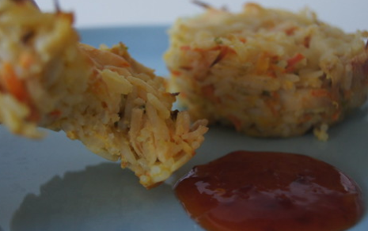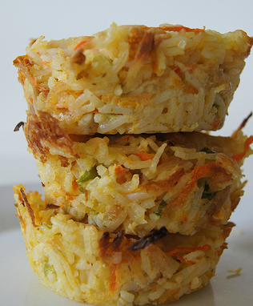Cavalry Primary School



Cookery Club

**Recipe Card**

**Chicken and Rice Patties**

Ingredients

* 3 cups cooked jasmin rice (about 1 cup uncooked)
* Packet of cooked chicken breast
* ½ tablespoon olive oil
* 1 large carrot
* 3 spring onions stalks
* 1 1/3 cups grated mozzarella cheese
* 3 eggs

Method

* Preheat oven to 200° Celsius.
* Shred up the chicken using a fork or your fingers.
* Grate carrot so you have at least 1 cup.
* Finely slice spring onions.
* Lightly beat the eggs.
* In a large bowl add cooked rice, chicken, carrot, spring onions, eggs and about ¾s of the cheese and mix well.
* Spray muffin trays with cooking spray and then spoon mixture into the trays. Top with remaining cheese.
* Place in the oven for 15 minutes until the tops turn golden brown.
* Let them sit in the trays for a few minutes before removing to rack to cool. Use a knife to work around the edges of the rice patties to make removing them easier. This recipe made 12 Chicken and Rice Patties. They can be eaten hot or cold- great for lunchboxes!

Week 3