Cavalry Primary School
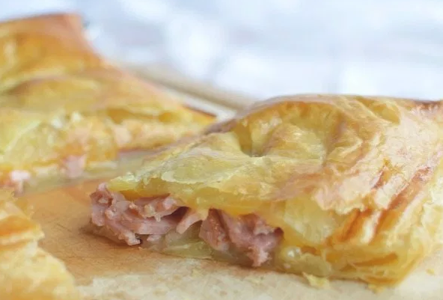
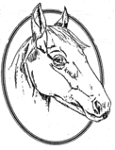

Cookery Club
Recipe Card
Festive Bake
Ingredients
- 2 Puff Pastry Sheets
- 1 packet of cooked turkey breast meat, torn
- 2 cooked sausages
- 1 onion, sliced
- 1 tbsp of cranberry sauce
- Pinch of sage
- 1 Egg & 1 Tablespoon Water, egg wash

Method
- Preheat oven to 180.
- Roll out one puff pastry sheet onto a greased baking sheet.
- Top the pastry with an even layer of cranberry sauce, turkey, sausage, onion and sage. Leave one inch of space between the filling and the pastry edge along the entire perimeter.
- Mix the egg and water together with a fork to create the egg wash.
- Brush the inside pastry edges with egg wash.
- Roll out the second puff pastry sheet and place on top.
- Completely seal the edges of the top and bottom pastry sheets by gently pinching together. (like a giant ravioli)
- Slice 3 slits into the top pastry sheet.
- Brush the top with egg wash.
- Bake on the centre rack for 20-25 minutes or until golden brown.

