CAVALRY PRIMARY SCHOOL

Cavalry Drive
MARCH
Cambs
PE15 9EQ
Telephone (01354) 652814
Fax. (01354) 658094
E-mail: admin@cavalryprimary.org
www.cavalry.cambs.sch.uk/

Welcome to our school! The governors, staff and pupils hope that your association with Cavalry School will be a happy one.

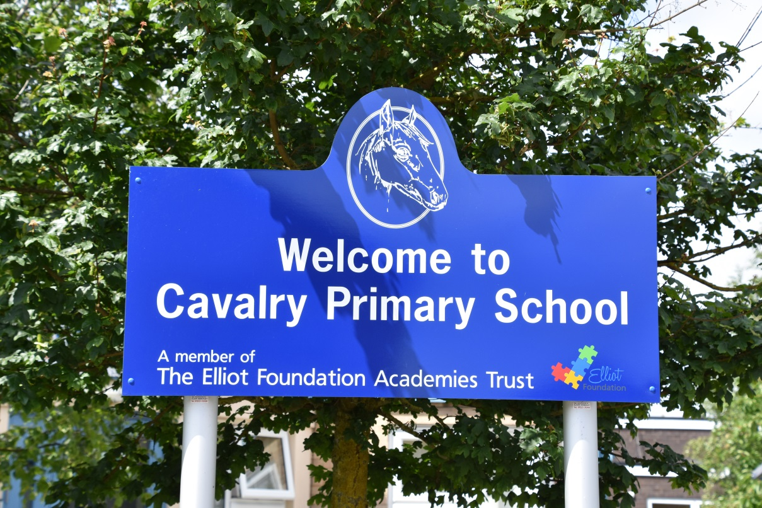

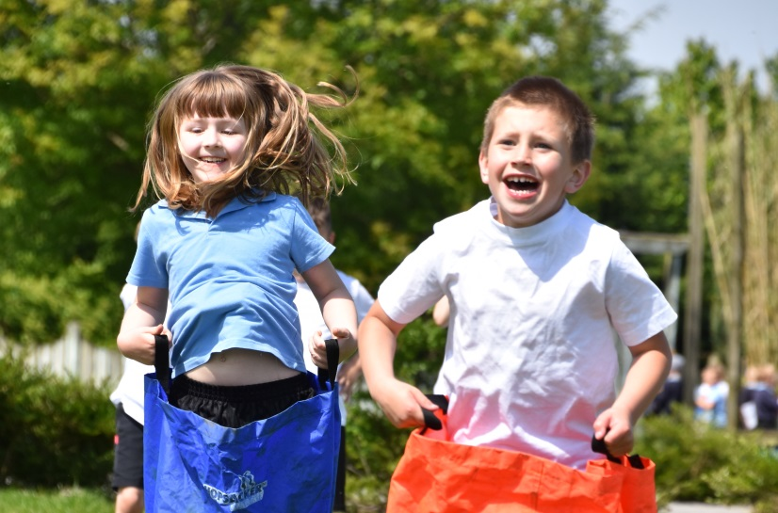

Our Aims

We organise our school so that we can

- Provide a happy and secure environment in which children can develop intellectually, emotionally, socially and physically

- Provide an exciting and challenging curriculum which encourages and motivates our children

- Assess and cater for the needs of each child

- Provide a sound foundation for future learning.

- Encourage children to become self-confident, independent and responsible.

- Work in partnership with parents in the education of their children and encourage parents to take a full part in the life of the school.

- Achieve effective communication between parents, children, staff, Governors and the wider community.

STAFF 2019 to 2020
Headteacher | Mrs F.McCallum
Deputy Headteacher | Mrs S. Edwards
Assistant Headteachers | Mrs S. Stanforth | Miss A. Ellis | Mr R Webb
Teachers | Miss J Abblitt | Miss J Goodman | Mrs J Nosworthy
 | Mr C Brown | Mr C Harding | Mrs E Roberts
 | Mrs J Cuthbert | Miss V Kavanagh | Mrs J Southby
 | Mr T Day | Miss U McAllister | Mrs E Turrell
 | Miss T Evans | Miss A Morris | Mrs R Warby
 | Miss J Gascoigne | Mrs E Morris | Mrs L Wilson
School Secretary | Miss K Hicks | Admin Assistant | Mrs T Band
Finance Manager | Mrs S Harker/Mrs K Conroy
Family Support Worker | Mrs A Deller
Teaching Assistants | Mrs C Bales | Mrs N German | Mrs N Pritchard
 | Mrs A Bates | Mrs H Greenleaves | Miss T Rayner
 | Mrs L Beeken | Mrs S Gull | Mrs V Rutter
 | Miss H Bedford | Mrs E Jackson | Miss L Sargeant
 | Miss L Blunt | Mrs M Keenoy | Miss S Snell
 | Mrs E Carey | Mrs N Kightly | Mrs C Spinks
 | Mrs T Carter | Mrs R Liversedge | Mrs N Stacey
 | Mrs M Collings | Mrs S McAnespie | Mrs P Tahir
 | Mrs K Conyard | Mrs S Mann | Mrs C Taylor
 | Miss C Coustol | Mrs J Mason | Mrs K Welbourne
 | Miss K Dickenson | Mrs N Monk | Miss F Wenn
 | Miss N Fox | Mrs R Owen
 | Mrs S Garner | Mrs K Poole
Nursery Leader | Mrs M Pughsley
Cleaner in Charge | Mrs A Deller/Mrs K Poole
Cleaners | Miss R Alderton | Mrs M Daniels | Mrs W Thompson
 | Mrs A Arnold | Miss T Rayner | Miss V Watson
 | Mrs L Cook
Lunchtime Supervisors | Mrs A Cross | Mrs R Frost | Mrs L Steventon
 | Mrs J Dunlop | Mrs S Lambert | Mrs W Thompson
 | In addition to a number of teaching assistants

SCHOOL ORGANISATION

Teachers and Classes

We have space for 60 children in each group, divided into two classes of about 30 pupils. Each class comprises children of mixed ability, and has the support of a teaching assistant alongside the class teacher. We identify and assess all pupils' individual needs and use schemes of work which challenge children of all abilities and reflect their interests and maturity.

Records are kept of work that each child has completed. These records provide vital information that is necessary to provide continuity for the child as he/she progresses through the school. Teachers undertake regular assessment of each child's progress and from the results plan future learning. Children undertake national statutory assessment tests (SATS) at the end of Key Stage 1 (5-7 years) and at the end of Key Stage 2 (8-11 years). The parents are given the results of these tests at the end of the Summer Term.

In addition, during May all children undertake tests which enable the school to assess their progress.
This information is invaluable to both parents and school. The dates are shared with parents and published on the website a year in advance.

We provide an annual written report to all parents on the educational achievement and progress of their child, along with a shorter written summary each term.

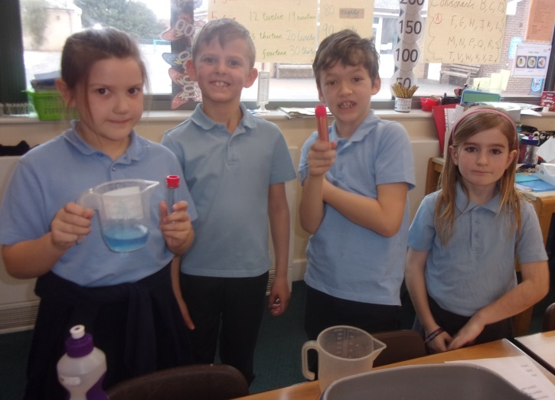

PARENTS AND SCHOOL

We believe that by working together staff and parents can provide the best learning opportunities for the children at Cavalry School.

This partnership begins before each child attends school. Families are encouraged to visit and see the school at work and to talk to the Headteacher. Links are established with parents as soon as children enter the nursery and an information evening is offered to new parents before children enter the Reception class. All parents will be asked to sign a Home School Agreement as required by the government.

Throughout your child's years at Cavalry School, staff encourage you to meet them regularly at parents' evenings. You may also make an appointment to see your child's teacher or the Headteacher at any time during the term.
There are opportunities for parents to attend meetings about various aspects of the school curriculum. A newsletter is written by every teacher at the beginning of each term to inform parents about the content of the coming term's work.

We encourage parents to take an active part in all aspects of school life by becoming Parent Governors on the Governing body. Some parents work regularly in the school library, or offer occasional help on school trips, while others volunteer to help in classrooms.

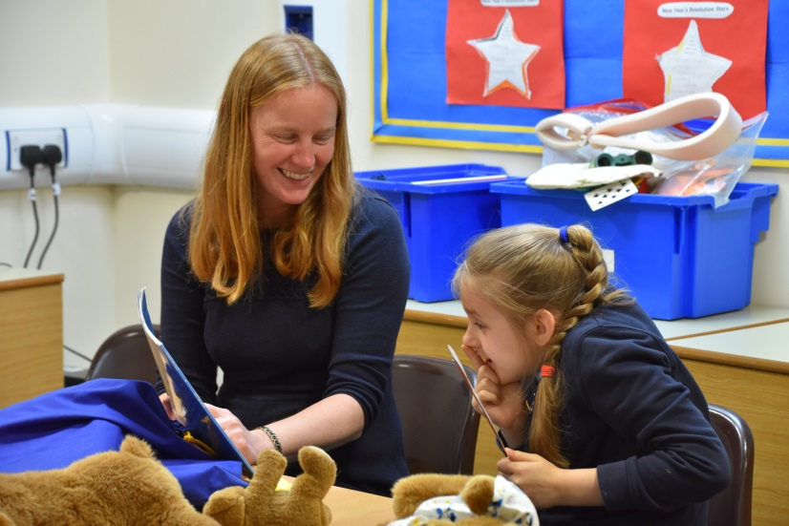

Admission of New Children
Parents and children are encouraged to visit the school and talk with the Headteacher. We do all we can to reassure new children and help them settle very quickly. Children and parents visit the nursery prior to starting and parents are encouraged to stay and play so that the child feels comfortable and settled. A number of informal events are held to allow parents to gain the knowledge that they need to support their children as they move to full time school attendance. New Reception children come on pre-school visits and they spend time joining in with the activities in the Reception classes. There is also an informal evening for their parents. The children begin school in small groups during the first two weeks of the Autumn Term.

Helping your Child at home
We encourage all children in school to take home simple tasks to extend their learning. We hope that parents will help and encourage them with this work.
All children begin by taking home a book to share with an adult and later as they learn to read we ask parents to hear their children read every night and comment on their progress in the 'Reading Together' booklet.

When the children are ready to begin to spell words independently, they are given short lists of words from the Cavalry School spelling pathway to learn.

Children are actively encouraged to learn their multiplication tables and number bonds.

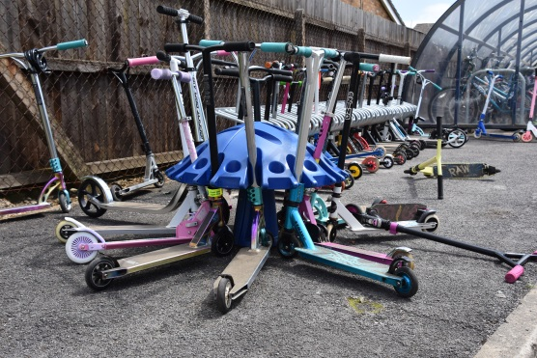

Concerns and Complaints

If you have any questions, worries or concerns about how your child is getting on at school, please speak to the class teacher in the first instance. If you feel that an issue has not been resolved, a member of the Senior Leadership Team will be able to meet with you and talk through your concerns. We hope that by working together and talking openly about any issue, the situation can be resolved informally. There is also a complaints procedure, which can be found on the school website or obtained from the school office.

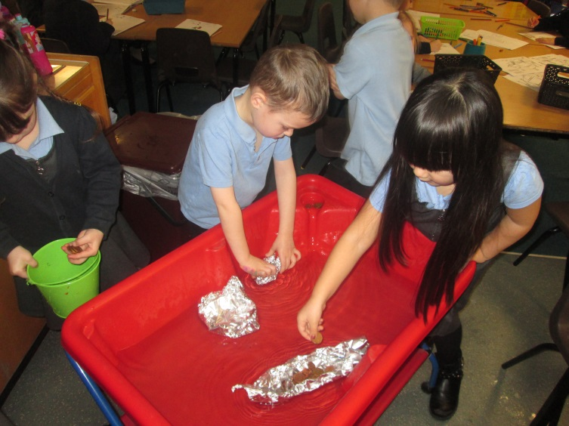

GOVERNORS

Chair Mrs A Betts

Vice Chair to be confirmed

Clerk to Governors Ms A Chandler

Foundation Governors Mrs A. Betts Mr B. Bullman
Mrs K Wilson

Co-opted Governor Mrs T Wilkes

Staff Governor Mr R. Webb

Parent Governors Mrs V. Ransome Mr D. Rose

The Clerk to the Governors can be contacted via clerk@cavalryprimary.org. The Chair of Governors can be contacted via the school office on 01354 652814 or admin@cavalryprimary.org

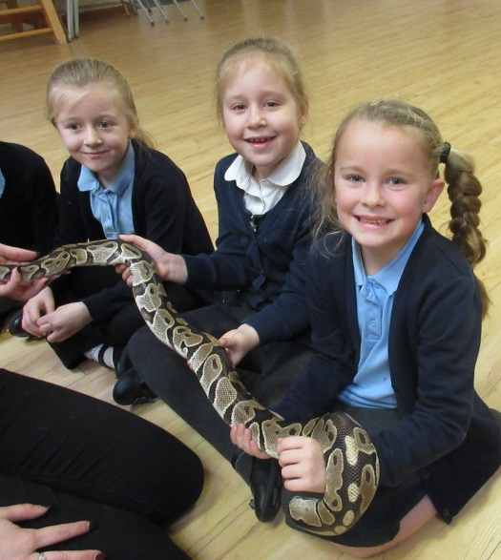

The Role of the Governing body and the Multi- Academy Trust

In March 2017 the school chose to become an academy and joined The Elliot Foundation Academies Trust (TEFAT). TEFAT is a collaboration of about 25 primary schools, who work together to provide mutual support and development. Our Local Governing Board has a general responsibility for the effective management of the school, acting within the framework of national legislation and the policies of The Elliot Foundation. They are not expected to take detailed decisions about the day to day running of the school – that is the role of the Headteacher.

The Local Governing Body meets twice each term, when the Headteacher reports on past activities and future programmes. Finance, property, safeguarding and pupil achievement feature on every agenda.

Any concerns expressed by parents about the school should be dealt with in informal discussion with the teachers and Headteacher in the first instance. However, where concerns cannot be resolved, the matter may be referred to the governing body. A copy of the Complaints Procedure is available by request to the school office and is published on the school website.

The Elliot Foundation is a charitable multi-academy trust specialising in primary academies. We are building a thriving community of schools including converter and sponsored primary academies that succeed on behalf of their children. We bring an understanding of the unique role of successful primary education as a pre- requisite for even greater success at secondary school level.
We are uncompromising in our search for excellence and in our commitment to sharing emerging best practice across our primary academy chain.

SCHOOL ADMINISTRATION

Times of the School Day

Breakfast Club 7.45 a.m. – 8.50 a.m. (£2.00 per session)

Morning Session 8.50 a.m. - 12.10 p.m

Morning Break 10.35 a.m. - 10.50 a.m. (Years 1, 2 & 3)
10.55 a.m. - 11.10 a.m. (Years 4, 5 & 6)

Lunch Break 12.10 p.m.-1.10 p.m.

Afternoon Session 1.10 p.m. -3.15 p.m.

Stay & Play 3.15 p.m. – 5.15 p.m. (£3.50 per hour)

Children may arrive in school between 8.40am and 8.50am when the register is taken.

Children who go home for lunch are asked not to arrive back at school before 12.50.p.m.

Uniform
All children are encouraged to wear school uniform. We suggest the following range of colours and styles:

Girls Boys
Navy/black/ grey skirt/ trousers grey/black trousers
pale blue blouse pale blue shirt
blue "polo"/sport shirt blue"polo"/sport shirt
navy v-neck sweater/cardigan navy v-neck sweater
navy sweatshirt navy sweatshirt
blue and white summer dress grey or navy shorts
black shoes black shoes

Navy sweatshirts with the school's logo are available and can be purchased from the School Office. Items embroidered with the school’s logo can also be purchased from the Tesco Uniform website.
Please ensure all articles of clothing are clearly marked with your child's name.
Children will also need a pair of plimsolls/trainers and a change of clothing for P.E. , for example, a leotard or white tee-shirt and black shorts, in a P.E. bag which is labelled on the outside. Warm clothing is needed in winter.
SCHOOL MEALS

School meals are provided by Lunchtime UK and are cooked on site. A wide variety of dishes are available to the children.

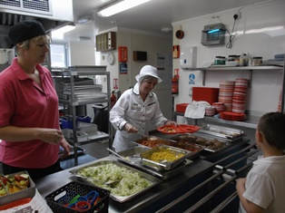 | 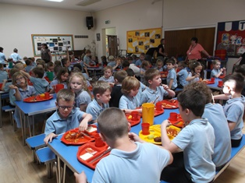

A free meal is provided for every child in Reception, Year 1 and Year 2. All other children pay for each meal taken. The cost is £2.30 per meal. A menu is published in advance, on a three week cycle, and children chose the main course they would like when they arrive at school in the morning so that the school kitchen can prepare the correct numbers

Dinner money is paid online via our ParentPay website, or a card can be provided which enables you to pay for school meals at any local shop with a PayPoint (such as the Co-op on Badgeney Road, Premier corner shop on St Peter’s Road or any of the local One-Stop Shops).

It is essential that all school meals are paid for in advance.

Some children prefer to bring a packed lunch which should be in a suitable named container. Canned drinks, glass containers and hot drinks in flasks are not allowed. Jugs of water are provided, but children should bring their own mug.

A piece of fruit is provided as a mid-morning snack for all children in Reception, Year 1 and Year 2. We encourage the children in Years 3, 4, 5 and 6 to bring a piece of fruit as well if they wish. We also encourage children to bring a named bottle of water to school in hot weather

Free School Meals/ Pupil Premium Funding

Did you know that you may be eligible to apply for free school meals for your child? Even if your child is in Reception, Year 1 or Year 2 it is worth applying because the school will receive an additional £1300 for your child to support their education in school, known as pupil premium funding. Once you have registered for free school meals, the school will receive pupil premium support for your child for six years, even if your financial circumstances change and you are no longer entitled to free school meals.

If you receive any of the following benefits, you can apply for free school meals/pupil premium:
- Income Support
- Income Based Job Seekers Allowance
- Child Tax Credit Only (with income up to £16,190) with no element of Working Tax Credit
- National Asylum Seekers Support
- Guarantee Element of the State Pension Credit
- Employment and Support Allowance (income related)
- Universal Credit (income dependant)

For pupil registered for free school meals or eligible for Pupil Premium, we can offer:
- A free place at Breakfast Club every day.
- Reduced cost of residential visits to Burwell House in Y3 and Wales in Y5/6
- Free instrumental music lessons in KS2 e.g. flute, clarinet, brass lessons
- Free places on school trips
- Additional help with learning when needed such as small group support, catch-up sessions and maths clubs.

If you think you may be eligible to apply, please make sure you supply your national insurance number on the admission form as this allows us to register your child. This extra funding makes a big difference to our school budget and can make a big difference for your child.

Extra-Curricular Activities

The school provides a number of clubs for children at the school. These include football, homework, multi-sports, athletics, speed stacking, choirs, hand chimes, steel pans, recorder groups and concert band. Children are encouraged to join in and extend the skills taught in lesson time.

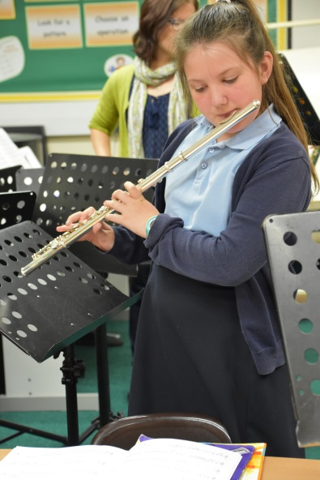

Charges for activities and school visits
A charge cannot be made for activities within the school day. This means that the school must meet the costs of all visits and outings. Whilst being desirable, such visits are not essential and costs incurred by the school would seriously affect the educational provision within normal school hours. The Headteacher will therefore request voluntary contributions from parents to cover the costs of all educational visits that take place in school time.

If sufficient voluntary contributions are not forthcoming the activity will not take place.

The policy of the governors is that no child should miss the opportunity to participate in a school visit through financial difficulty. Children who have registered for the Pupil Premium automatically have a free place on school trips. Other families may also find that there are times when financial circumstances are difficult, and may make an appointment to discuss their individual circumstances with the Headteacher. All such enquiries are dealt with quietly and confidentially.
A full copy of the Charging and Remissions policy is available for parents to see on request and on the school website.

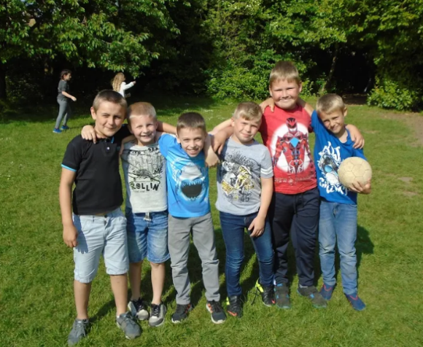

RESIDENTIAL VISITS

We offer all children the opportunity to take part in two residential visits during their time at Cavalry School. The first of these takes place in Year 3 and is usually a three day visit to Burwell House Residential Centre near Cambridge, which is owned and run by Cambridgeshire County Council.

In Year 5 we offer a full week's visit to an Outdoor Education Centre in Wales. Here the children have the chance to try climbing, hill-walking and abseiling under the direction of fully trained instructors, and, of course, to enjoy the adventure of being further away from home and in an unfamiliar environment. They are also given tasks linked to their National Curriculum studies in geography and science.

Both of these visits are of course optional but we feel that they enhance the work that we do in school, and are character-building experiences which offer children a wonderful opportunity to become more independent.

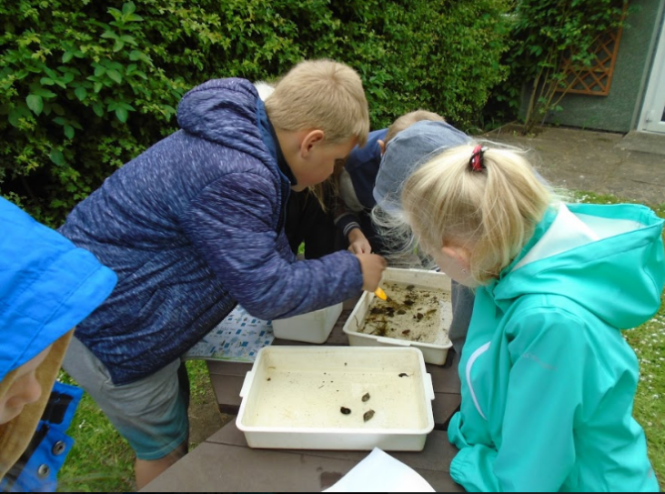

PASTORAL CARE

Discipline

We aim to build a sense of community where emphasis is placed on

- a positive attitude of praise and encouragement and recognition of achievement and good behaviour.

- showing respect for each person and treating everyone as an individual.

- showing kindness and consideration for others.

- working with parents in order to promote good behaviour and inform them fully of the school's approach to discipline.

We take a serious view of bad behaviour, and we are alert to bullying and signs of racial harassment, taking firm action when necessary. We encourage pupils to tell us if they believe they are being treated unfairly. You can read our behaviour and anti-bullying policy in full on the school website.

We celebrate pupils' achievement and all children are given opportunities to share their successes in our weekly Achievement Assembly.

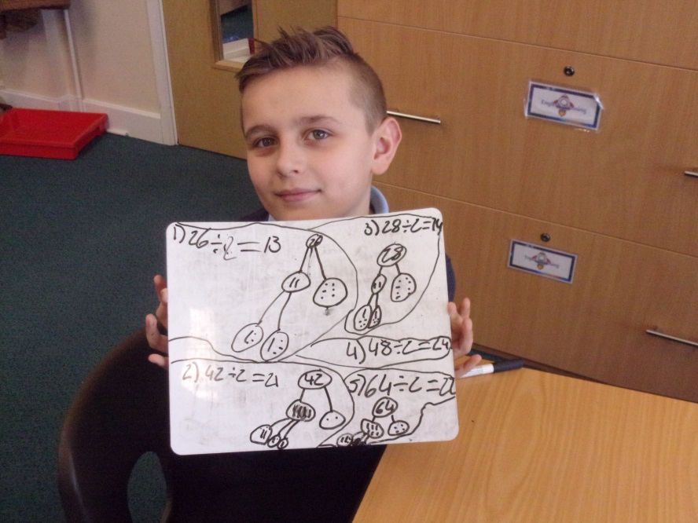

Our school rules:

At Cavalry School, we ask everyone to be

- ready – ready to learn, ready to listen, attending school each day
- respectful – to other children, to adults and to visitors
- safe – making sure we behave in ways that keep ourselves safe and everyone around us safe.

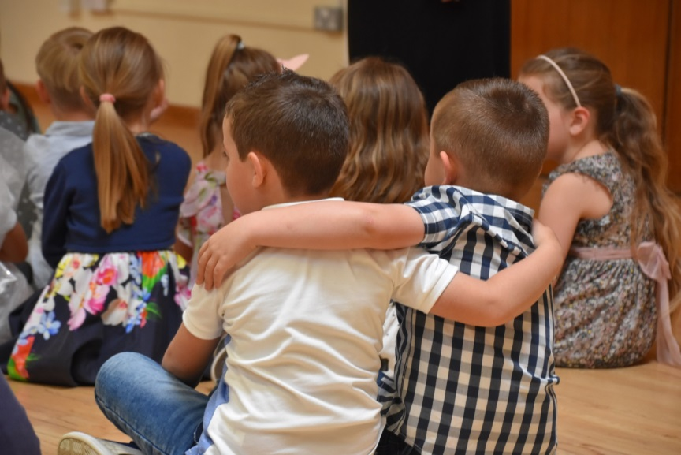

HEALTH AND WELFARE

First Aid

Thirteen members of our staff hold a first aid qualification. Records are kept whenever first aid is administered and for minor bumps and scrapes, parents are informed via a paper slip sent home in the school bookbag. If an injury appears to be more serious, of course we inform parents immediately. We apply plasters to minor cuts so please tell us if your child is allergic to plasters.

Illness at School

Children are occasionally unwell during the course of the school day. It is very important that we have a telephone number through which we can contact parents, or a named representative, should the need arise. Please inform us immediately if your address or contact numbers change, as inaccurate information could cause delay resulting in distress for your child.

Medical information
It is essential that you inform the school if your child has a serious or recurring medical problem. Any information of this nature is, of course, treated confidentially.

Medicines
In certain circumstances children at school may need prescribed medication. Medicine can only be given as prescribed by a doctor, and a signed request form must be completed at the school office so that the school has the authority to give the prescribed dosage. Medicines must be brought to school by an adult and handed in to the school office.

With the exception of asthma inhalers, epi-pens and insulin pens, all medicines are stored in a locked cupboard in the school office. Inhalers are kept in a labelled box on a high shelf in the classrooms. Parents of children requiring inhalers are requested to ensure that a named inhaler is on the school premises at all times

Should you require advice or help with any issue relating to health or your child, please speak to the school nurse. You can leave a message with the school office staff, who will be happy to contact our school nurse and arrange for her to telephone you.

Safety Procedures

Parents who bring and collect children by car must not drive or park in the driveway, or in the designated bus bay. The Road Safety Officer supports the school in asking that all parents exercise the utmost care when parking near school and when driving away. The area PCSO visits school regularly to check that parents park legally and safely.

The School Crossing Patrol lady, Mrs S. Lambert, is on duty in Upwell Road at the beginning of morning session and at the end of the school day, to supervise children crossing.

Please do not park or drop off on the yellow lines from 8.30am – 9.00am or
3.00 – 3.30 pm.

Please park with consideration for the neighbours of the school. It is important not to block driveways or park too close to any junction.

Because of our concern for children's safety, particularly in P.E.,
school rules state that children are not allowed to wear jewelry other than a watch and one stud ear-ring in each ear, in school .

Wearing jewelry during P.E. lessons is dangerous and so children are required to remove watches, and ear-rings for these lessons, in accordance with Cambridgeshire County Council’s health and safety policy.

If your child has pierced ears, please use studs and not ear-rings that dangle, as these can catch and damage children’s ears. Parents of children who are unable to remove their own ear-rings are requested not to send them to school wearing them on P.E. days.

The school does not accept responsibility for any jewelry worn in school.

Children may leave a cycle on the premises only when accompanied to and from school by a responsible adult. NB All children must wear a cycle helmet. There is also a space to park scooters. Please be aware that the school cannot accept any responsibility for bikes or scooters which are left on the premises during the day and we advise parents to lock bikes securely.

To ensure the children's safety, all gates giving access to the rear of the school are kept locked between 8.55a.m. and 3.10 p.m. Parents, children and visitors arriving at the school after 8. 55 a.m. are asked to press the buzzer by the main front door and wait to be admitted.

Family Worker

Our school family worker is Mrs Alison Deller. Her role is to provide a listening ear and support or advice to all our families. Many parents, at one time or another, find some aspect of bringing up children hard work, whether it is establishing good bedtime routines, coping with children who don’t want to come to school or dealing with challenging behaviour between siblings. Sometimes other circumstances make family life hard, such as divorce, separation, bereavement or financial worries. Any parent can speak in confidence with Mrs Deller to access support or signposting to other organisations. You can arrange a convenient time to talk with Mrs Deller by ringing the school office.

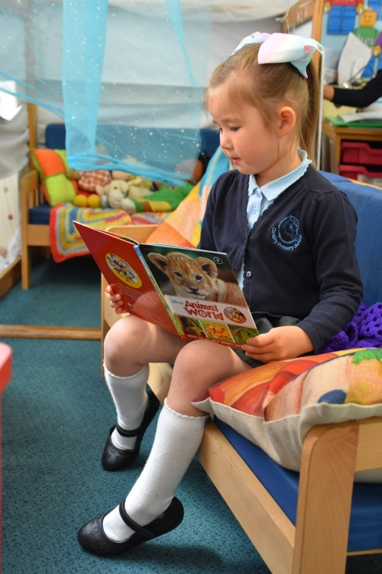

Child Protection

Under the Education Act 2002 (section 175/157), schools must “make arrangements to safeguard and promote the welfare of children”. All school employees and volunteers are subject to the full range of safeguarding checks before they begin to work with children, including DBS checks, taking references and checking qualifications.

We will endeavour to provide a safe and welcoming environment where children are respected and valued.
The school will therefore be alert to signs of abuse and neglect and will follow the Local Safeguarding Children Board (LSCB) procedures to ensure that children receive appropriate and effective support and protection.

Mrs McCallum is the Designated Safeguarding Lead for the school and nursery. Mrs Stanforth and Mrs Deller are also trained as Designated Safeguarding Leads. Every member of staff receives regular training in child protection.

Parents/carers should know that the law requires all school staff to pass on information which gives rise to a concern about a child’s welfare, including risk from neglect, physical, emotional or sexual abuse. The school should make parents/carers aware that records of welfare concerns may be kept about their child. They should be informed that school staff will seek, in general, to discuss any concerns with them including referrals to other agencies. However, in situations where the child is suspected to be at risk of harm, the law says that schools may take advice from other agencies without informing parents/carers.

In accordance with local Information Sharing protocols, we will ensure that information is shared securely and sensitively. Information will only be shared with other services where it is deemed necessary and proportionate to ensure that children and young people are safe and receive the right service.

Schools will seek advice from Social Care when they have reasonable cause to suspect a child may be suffering or likely to suffer significant harm. Occasionally, concerns are passed on which are later shown to be unfounded. Parents/carers will appreciate that the member of staff in the school with responsibility for child protection (known as the Designated Safeguarding Lead) was carrying out their responsibilities in accordance with the law and acting in the best interests of all children.

Under Section 3 (5) of the Children Act 1989, schools or any person who has care of a child “may….do what is reasonable in all the circumstances of the case for the purpose of safeguarding or promoting the child’s welfare”. This means that on rare occasions, a school may need to “hold” a child in school whilst Social Care and the police investigate any concerns further.

If you have any concerns about the safety or wellbeing of any child in our school or nursery, please ask to speak in confidence with one of the Designated Safeguarding Leads. Any member of the community can also share concerns with the relevant agencies by calling the NSPCC helpline on 0808 800 5000.

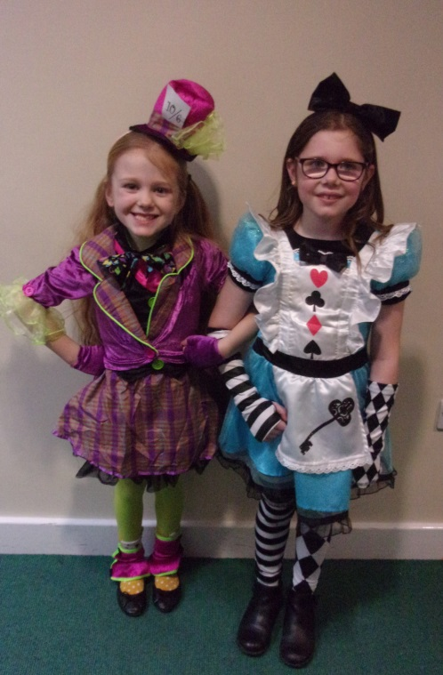

Absence from school

Please inform the school as soon as possible on the first day of absence, and also every day thereafter, if your child is unwell or has to attend a hospital or dental appointment. Messages can be left on the school answering machine at any time and the office is staffed from 8.30 a.m. onwards.
All absences are recorded. Unauthorised absence, that is those for which we have not received a letter or telephone call with an acceptable explanation for the absence, will be shown on pupils’ reports and may lead to a referral to the Education Welfare officer.

Parents are not entitled to take their child out of school for annual holidays. Term time holidays will not be authorised and may lead to a fixed penalty notice issued by Cambridgeshire County Council.

Each week the school registers are checked for absenteeism. The parents of pupils who have been absent and from whom we have received no explanation will be contacted asking for details. Persistent absence will be followed up by the Educational Welfare Officer and parents may face court action and fines.

Parents are reminded that it is their legal duty to ensure that children attend school daily and that they arrive at school in good time as latecomers cause considerable inconvenience to class teachers and disrupt the learning of other pupils. The school has a legal obligation to record all absence and lateness. Children arriving after morning registration are required to report to the office so that their names can be recorded.

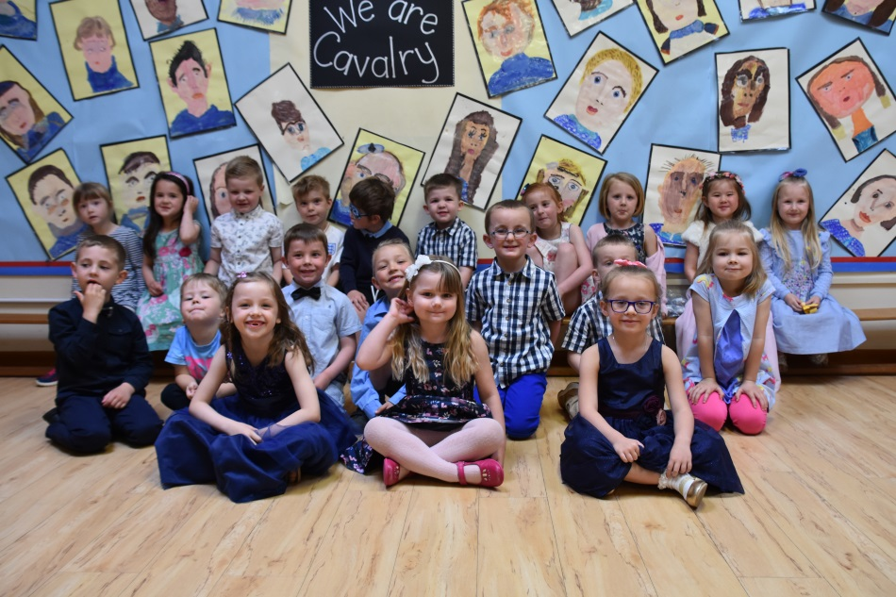

SPECIAL EDUCATIONAL NEEEDS AND DISABILITIES

We have clear identification and assessment procedures that enable us to identify pupils with special needs. Teaching is carefully matched to their needs and we use professional support services and consult regularly with parents about the provision for their child. The school has all facilities required to accommodate most children with physical disabilities and is happy to discuss any individual cases with parents. Further information can be accessed via the school’s SEND Information Report on the school website – this sets out in detail all the approaches we use for a range of special needs and disabilities, including for children with speech, language or communications, needs, autistic spectrum disorder, ADHD or specific learning difficulties.

If you have any concerns about your child’s additional or special educational needs, please speak to the class teacher in the first instance. Our SEND
Co-ordinator, Miss Evans, is also available for advice and support.

Equal Opportunities

We believe that all pupils are of equal value, regardless of their gender, race, ability or background. We aim to ensure that all have access to the National Curriculum and appropriate access to the resources and opportunities available at Cavalry School. Parents can obtain copies of our Equality Scheme and Accessibility Plan via the school office.

THE FOUNDATION STAGE

Activities for the Reception children are planned from the Foundation Stage Curriculum. There are seven areas of learning. These are divided into three prime areas – Personal, Social and Emotional Development, Physical Development and Communication and Language; and four specific areas – Literacy, Maths, Understanding the World and Expressive Arts and Design. The curriculum also focuses on how the children learn, looking at the characteristics of learning:

- Playing and exploring – engagement
- Active learning – motivation
- Creating and thinking critically – thinking

Personal, Social and Emotional Development

Children listen to stories and take part in activities that help them to consider their own feelings and those of others. They are encouraged to take turns and share. Self-esteem and confidence are developed through small group activities and the children are encouraged to be independent learners.

Communication and Language

Children are encouraged to speak confidently and clearly, and to listen carefully. They are given opportunities to share a wide range of poems and stories to extend their vocabulary. Children are encouraged to share their thoughts, ideas and feelings.

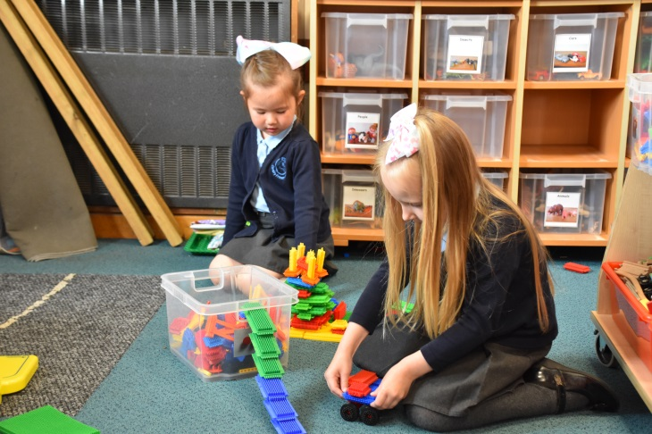

Physical Development
This area of development refers to developing a child’s fine and gross motor skills, as well as the child’s ability to take care of themselves and to learn about being healthy.
The children develop their physical skills in the classroom, where they cut out shapes, and use jigsaw puzzles and construction kits. They also have P.E. lessons where they have opportunities to climb and balance, run, hop and jump, and practice their throwing and catching skills. All of these skills are practiced in the outdoor environment too.

Literacy

Children are encouraged to develop their writing skills in the role-play area and in their writing books. They read as part of the literacy session and develop a love of story through using story sacks and by re-telling stories.

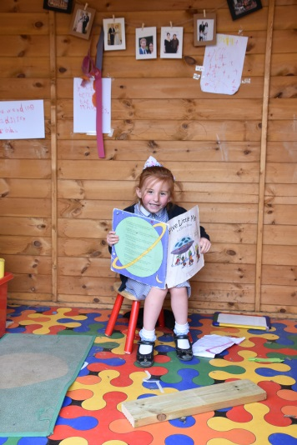 | 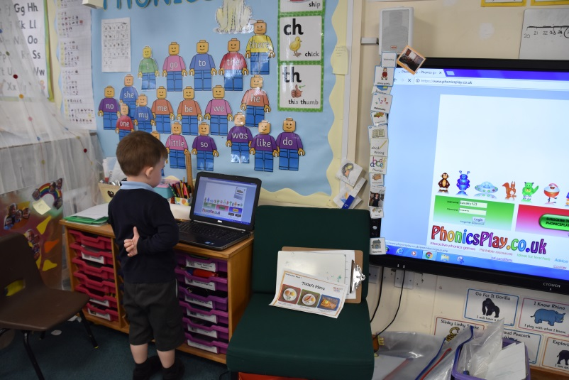

Mathematical Development

Activities include counting, number work, practical addition, shape work, weighing and measuring. Children are encouraged to use maths in role play activities such as buying and selling in the class shop.

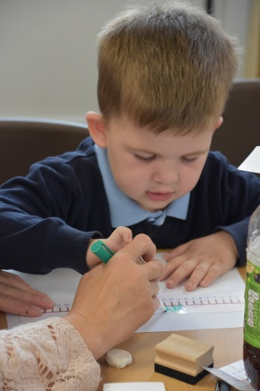

Understanding the World

This area of learning lays the foundations for the Science, History, Geography, ICT and Design Technology that will follow on in later years. Activities range from exploring the environment to making models and are planned to develop the children’s curiosity. They celebrate festivals from many different cultures. In R.E. they share stories from The Bible and other special books.

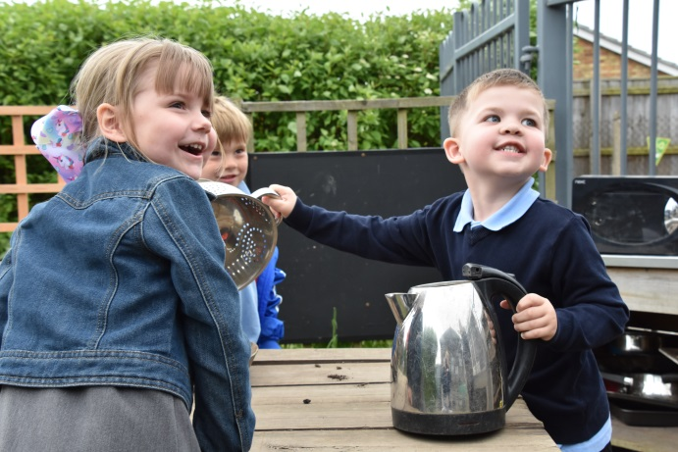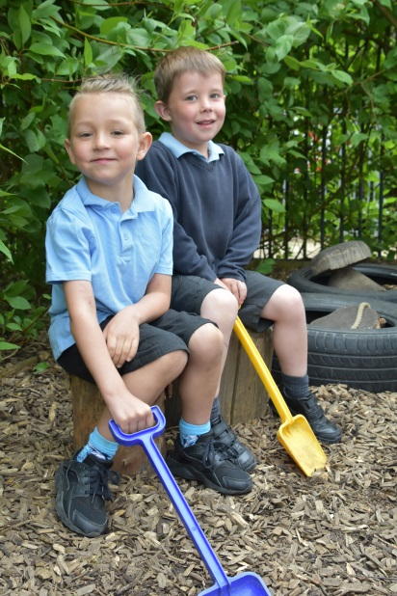

Expressive Arts and Design

Children learn simple songs and explore rhythm patterns in their music sessions. They are taught to handle musical instruments with care. Creative development also includes lessons in colour mixing when painting, and beginning to draw from observations. Opportunities to take part in role play activities help to develop imagination, as well as small world play.

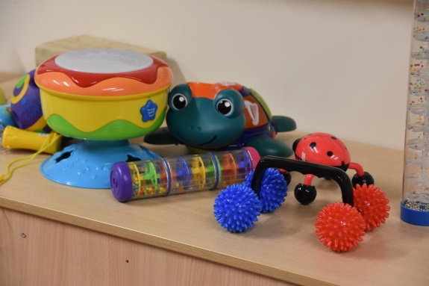

ORGANISATION OF THE NATIONAL CURRICULUM

All children in Years 1- 6 follow the National Curriculum which aims to ensure that all pupils receive a broad and balanced education which is relevant to their needs.

It consists of three core subjects- English, Mathematics and Science and seven other subjects - History, Geography, Technology, Art, Music, Physical Education, Foreign Languages and Computing.

Religious Education is taught under Cambridgeshire’s Agreed Syllabus. Personal, Social, Health and Citizenship Education (PSHCE) also forms an important part of the school curriculum.

CORE SUBJECTS

English

Reading
Reading is given very high priority at Cavalry School. As well as developing reading skills we foster a love of reading and of books.
During their daily English lesson, children are taught all of the basic skills which enable them to become confident fluent readers. We place great emphasis on the teaching of phonic skills which allow children to become independent writers from an early stage as well as to decode unfamiliar words when reading.
In addition to the work carried out in class, each child follows a "Home Reading Pathway" through a core scheme supplemented with a variety of carefully graded reading books. Children take these books home every night to share with their parents and we have a "Reading Together" book for teacher and parent to share information about the child's reading experience.

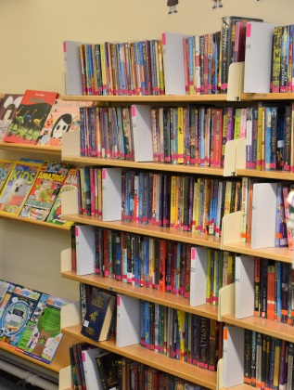

Each child's path along the journey to independent reading is carefully guided by the teacher and we place great value on the partnership which develops between home and school in the teaching of reading.
Cavalry School has a well-stocked library and children are encouraged to borrow books from the graded fiction collections available in classrooms. They visit the library in groups on a regular basis to develop research skills

Writing
From a very early stage children are encouraged to write for a wide variety of audiences and purposes.
Children are taught to form letters correctly and to use a style which enables them to learn joined up writing from an early age. All children have regular handwriting practice throughout their school years.
Correct spelling is developed through a planned programme appropriate to the requirements of the national curriculum. Grammar and punctuation skills are taught to every age group, sometimes through separate lessons but often as an integral part of writing activities.

Speaking and listening
Children are encouraged to listen carefully and to communicate clearly, and are given opportunities to develop these skills through a variety of speech and drama activities.
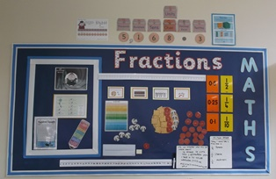

Mathematics
Children participate in a daily maths lessons in which there is very strong emphasis on the development of mental strategies. All children follow the national curriculum for maths and are involved in tasks which encourage them to develop the understanding and skills needed to deal with mathematical problems in everyday life. Accuracy, fluency and mathematical reasoning are key skills which we develop in all age groups.
We consider it important that children learn multiplication tables and develop basic computational skills and we value the support which parents give to such learning at home.
Science
We ensure that the children's experience is based on practical activity. The teachers give children the opportunity to participate, to observe, to ask questions and to find answers themselves through carefully planned experiments, to find patterns, to reason, to see the implication of scientific study in everyday life and to record these in various ways. They learn about plants, animals and the human body. They study materials and their properties, and begin to find out about forces, light, sound and space.

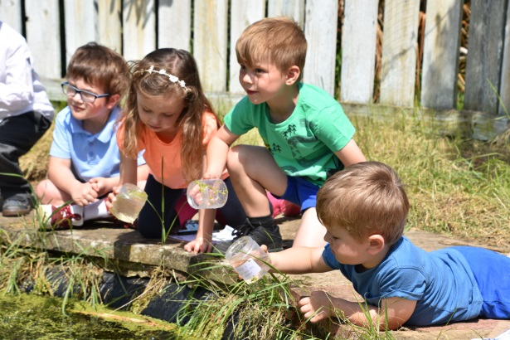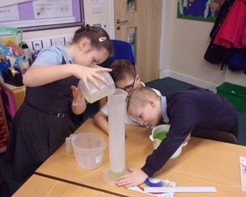

FOUNDATION SUBJECTS

Art
All the children are encouraged to acquire and develop skills of awareness, observation, discrimination and design. They have the opportunity to use a variety of media and a range of techniques.

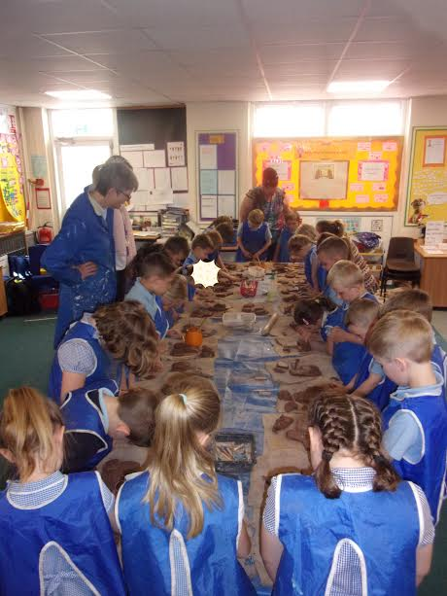

Geography
Children are given opportunities to develop their knowledge and understanding of their own and other people's environments. They are taught geographical skills which help them to appreciate the earth's natural resources. All children have the opportunity to explore the environment outside school through walks, day visits and residential visits. Three and five day residential visits are offered to Key Stage 2 pupils.

History
Children are encouraged to develop an awareness of the past and use a variety of historical sources to stimulate their learning. Educational visits are organised to enrich the children's experiences.

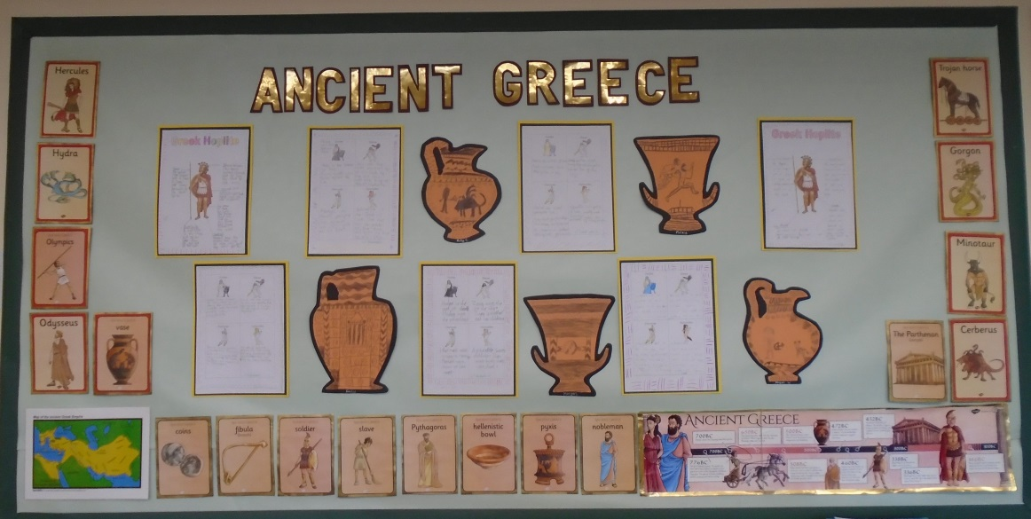

Music
All children regularly join in with listening to and making music. They have the opportunity to sing and play instruments. Older children are able to learn to play the recorder. Brass and woodwind instrumental tuition is also available.

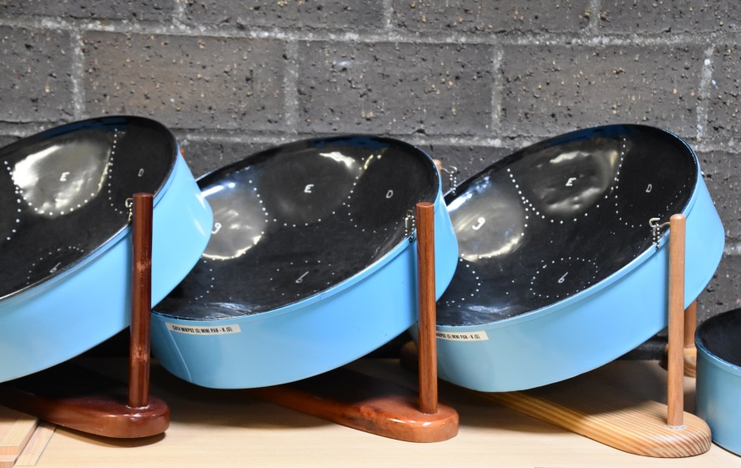

Physical Education
All children experience the key areas of gymnastics, dance, athletics and games in every year group. In the early years, skills are developed which enable progression to organised games such as hockey, football, netball, 'Kwik' cricket, rounders and 'short tennis'.
Additional practice in these games is offered at a variety of after-school clubs. Key Stage 2 pupils have swimming lessons at the George Campbell Pool in March.

Design Technology
This subject involves practical design and making opportunities for all the children, using a range of materials and equipment. It includes making models with paper, card and recycled materials, along with sewing/textile projects and cooking food.

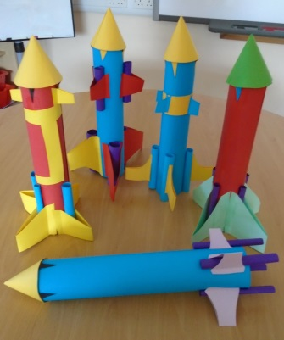

Religious Education
Religious Education and collective worship is provided in accordance with the Education Reform Act 1988 and collective worship takes place each day. We use the Cambridgeshire Agreed Syllabus to help us to plan our curriculum for the school. The children learn about Christianity through the key aspects of stories, places of worship, people and beliefs, rites of passage and festivals. In Key Stage 1 children also begin to learn about Sikhism, and in Key Stage 2 they are introduced to the other world faiths: Islam, Hinduism, Judaism and Buddhism. The aim of the curriculum in RE is to allow children to learn about and from religions, but we do not seek to teach the children to follow any specific religion or beliefs.

Should you wish to withdraw your child from Religious Education or Collective Worship, please contact the Headteacher who will ensure that alternative arrangements are made for him/her.

Computing

The school is very fortunate to have a large number of up to date multi-media computers and tablets loaded with excellent software. These are available to children throughout the school and allow children safe access to the internet. All classrooms are equipped with an inter-active whiteboard and computer. Children have opportunities to work with word-processing, spreadsheets, desktop publishing and data handling as well as experiencing a variety of simulation and control packages. Programming skills are taught using software packages such as “Scratch”.

Personal, Social, Health and Citizenship Education

All children follow the Cambridgeshire Personal Development Programme. Weekly lessons cover a wide range of themes, such as personal safety, building friendships and rights, responsibilities and rules. We also have regular ‘theme’ weeks such as learning about safety on the internet, safer cycling training in Year 5 or national anti-bullying week. We use materials from the NSPCC to help young children learn about keeping safe from abuse, and NSPCC’s Child Line team visit to work with the older children. For older children there are specific units of work about managing finances, keeping safe around drugs and medicines and preparing for puberty. Information about PSHCE is shared with parents through the termly Link Letters or by separate letter. Parents can find out more about our Sex and Relationships Policy via the school website.

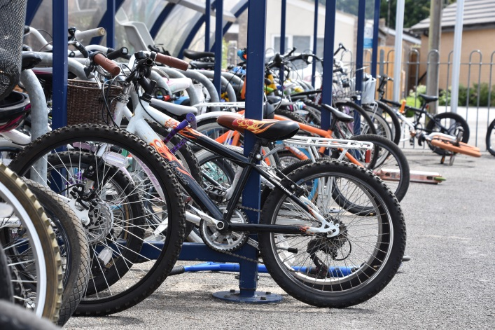

KEEP IN TOUCH

- Make sure your contact details are up to date by telling the school office if you move house or get a new mobile phone number. Keep your details up to date in ParentPay so that we can send you emails and texts.
- Visit our school website www.cavalry.cambs.sch.uk to see photos of the children at work and play, and to check term dates or find policy documents. We update the website regularly, including adding new pages about each class every term.
- Follow us on twitter…we ‘tweet’ about school activities every week, often with photos too. You don’t have to be a regular user of twitter as you can access our tweets through the website too.
- Email us on admin@cavalryprimary.org. Messages are checked regularly throughout every school day and this is a great way to book sessions at Breakfast Club or Stay & Play. The school office pass messages on to teachers, who are always happy to phone you or meet you for a chat.

