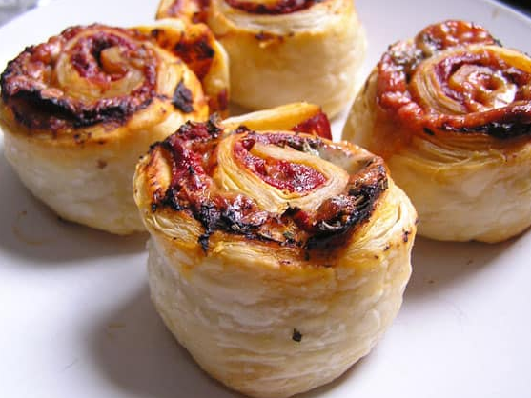
Cavalry Primary School
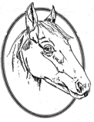

Cookery Club
Recipe Card
Pizza Wheels
Ingredients
- Tomato puree
- Cheese
- Mixed herbs
- Ready rolled puff pastry

Method
- Pre-heat the oven to 180C
- Line a baking tray with grease proof paper
- Lay the puff pastry sheet out and spread with tomato puree
- Sprinkle with Italian Herbs
- Add the grated cheese
- Roll up the puff pastry and cut into 8 wheels
- Place in the centre of the pre-heated oven for 15 to 20 minutes until golden brown and the puff pastry has puffed

NB: You can also make sweet versions using chocolate spread or jam.

Week 1

