Cavalry Primary School
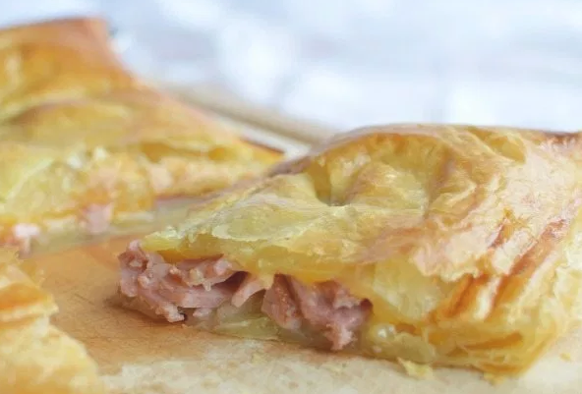
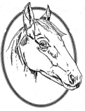

Cookery Club
Recipe Card
Ham and Cheese Bake
Ingredients
- 2 Puff Pastry Sheets
- 1 packet of ham, torn
- 1 Cup grated cheese
- 1 Egg & 1 Tablespoon Water, egg wash

Method
- Preheat oven to 400°F
- Roll out one puff pastry sheet onto a greased baking sheet.
- Top the pastry with an even layer of ham and cheese. Leave one inch of space between the filling and the pastry edge along the entire perimeter.
- Mix the egg and water together with a fork to create the egg wash.
- Brush the inside pastry edges with egg wash.
- Roll out the second puff pastry sheet and place on top of the ham and cheese.
- Completely seal the edges of the top and bottom pastry sheets by gently pinching together. (like a giant ravioli)
- Slice 3 slits into the top pastry sheet.
- Brush the top with egg wash.
- Bake on the centre rack for 20-25 minutes or until golden brown.

