Think of a Number
0 |  | Around to the left to find my hero,  Back to the top, I’ve made a zero.
1 |  | Downward stroke, my that’s fun,  Now I’ve made the number 1.
2 |  | Half a heart says, ‘I love you.’  A line- now I made the number 2.
3 |  | Around the tree, around the tree,  Now I’ve made the number 3.
 |  | Down and across and down once more. Now I’ve made the number 4.
5 | 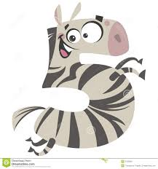 | The hat, the back, the belly- a 5.  Watch out! It might come alive.
6 | 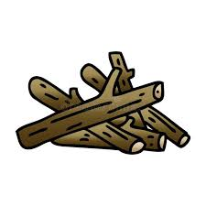 | Bend down low to pick up sticks,  Now I’ve made the number 6.
7 |  | Across the sky, and down to heaven,  Now I’ve made the number 7.
8 | 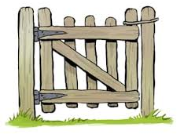 | Make an ‘S’ and close the gate,  Now I’ve made the number 8.
9 |  | An oval and a line,  Now I’ve made the number 9.
10 |  | One (1) egg (0) laid my hen.  Now I’ve made the number 10.

