Cavalry Primary School
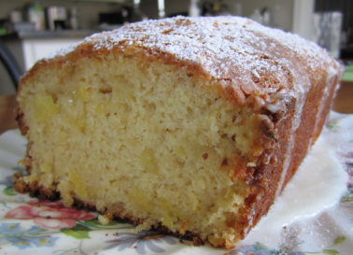

Cookery Club
Recipe Card
Pineapple Cake
Ingredients
- 2 cups self-raising flour, sifted
- 1 cup caster sugar
- 1 can (440g) crushed pineapple in syrup or juice, undrained

Method
- Preheat oven to 180°C. Line a loaf tin with baking paper and set aside.
- Mix all ingredients together until well combined.
- Pour into the loaf tin and bake for 55-60 minutes.

Week 4

