Cavalry Primary School
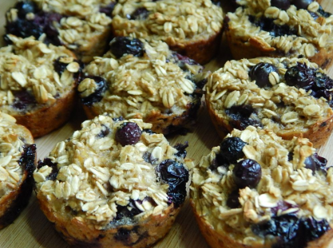

Cookery Club
Recipe Card
Banana and Blueberry Breakfast Muffins
Ingredients
- 180 grams oats
- 2 bananas
- 2 eggs
- 2 tsp Vanilla extract
- 2 tsp baking powder
- Blueberries
- 190 °C in the oven for 18 minutes

Method
- Pre-heat your oven to 190 degrees C.
- Mix together the oats & baking powder.
- Add the mashed bananas & stir with a fork before mixing in the blueberries (gently!)
- Whisk together the egg & vanilla before folding into the mixture until all of the dry mixture is coated
- Divide into paper muffin cases.
- Bake for 18 minutes until cooked, then allow to cool.
- Enjoy! These muffins can be kept in the fridge or in a cool cupboard. They can also be frozen for later.

Week 2

