Cavalry Primary School
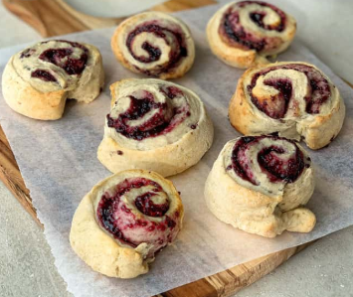

Cookery Club
Recipe Card
Raspberry and marshmallow pinwheels
Ingredients
- 6 tbsp of raspberry jam
- 2 cups of mini marshmallows
- 2 sheets puff pastry
- Milk for brushing
- Flour for dusting

Method
- Pre-heat oven to 220c (200c for fan assisted ovens) gas mark 7.
- Unroll the pastry sheet. Spread the jam evenly with a knife and sprinkle over the marshmallows.
- Roll up from the longest side like a swiss roll. If time, chill in the fridge for 20 minutes.
- Cut into 1 1/2 cm slices and place on a lightly greased or lined baking tray.
- Brush with milk.
- Cook for approximately 7-10 minutes until golden and risen. Cool on a wire rack. These are best served warm but can be left to cool completely then store in an airtight container. You can also freeze them for up to 3 months.

