Cavalry Primary School
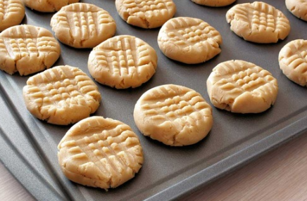

Cookery Club
Recipe Card
Chocolate Orange Fork Biscuits
Ingredients
- 100g (4oz) butter
- 50g (2oz) caster sugar
- 150g (5oz) self-raising flour
- Zest of one orange
- 1 bag of chocolate chips

Method
- Preheat the oven to 180°C /fan 160°C/ gas 4.
- Lightly butter two baking trays.
- Measure the butter into a bowl and beat to soften.
- Gradually beat in the sugar and then the flour.
- Grate in the zest of one orange.
- Add the chocolate chips.
- Bring the mixture together with your hands to form a dough.
- Form the dough into 16 balls about the size of a walnut and place spaced well apart on the prepared baking trays.
- Dip a fork in a little water and use this to flatten the biscuits.
- Bake in the preheated oven for 15–20 minutes until a very pale golden. Lift off the baking tray and leave to cool completely on a wire rack.

